Test Case: tc006_SPX_Dev5_Crear_Requisicion_Spot_Tipo_Cobro_Proyect_Urgent
Step 1 - Enter username and password and click to button Enter: Credentials Entered
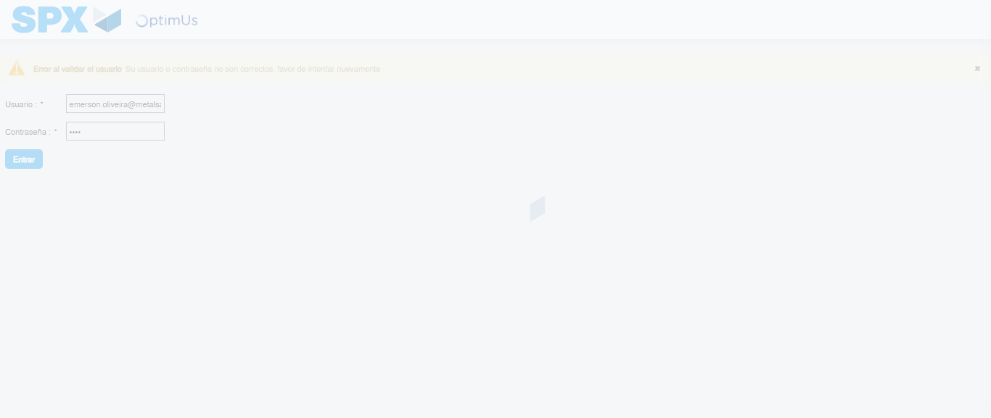Image file-name: QC_Testing-tc006_SPX_Dev5_Crear_Requisicion_Spot_Tipo_Cobro_Proyect_Urgent-1787009524392

Step 2 - Select to UEN and Access to Spot Buy Requisitions : UEN Correctly selected and Correct access
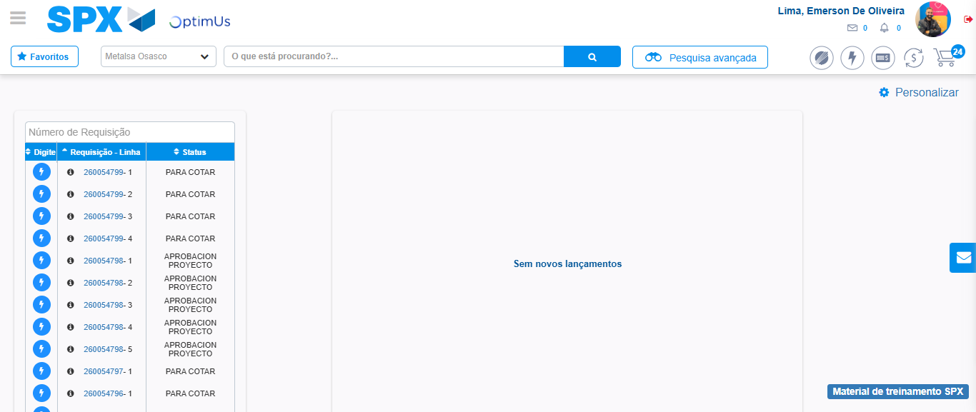Image file-name: QC_Testing-tc006_SPX_Dev5_Crear_Requisicion_Spot_Tipo_Cobro_Proyect_Urgent-1787009601451

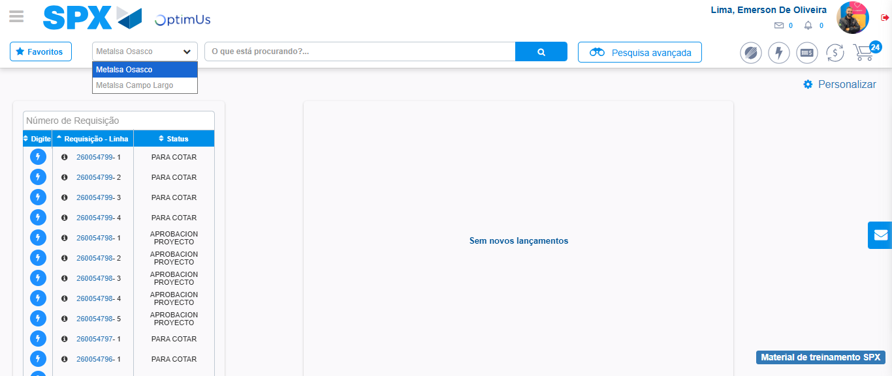Image file-name: QC_Testing-tc006_SPX_Dev5_Crear_Requisicion_Spot_Tipo_Cobro_Proyect_Urgent-1787009604092

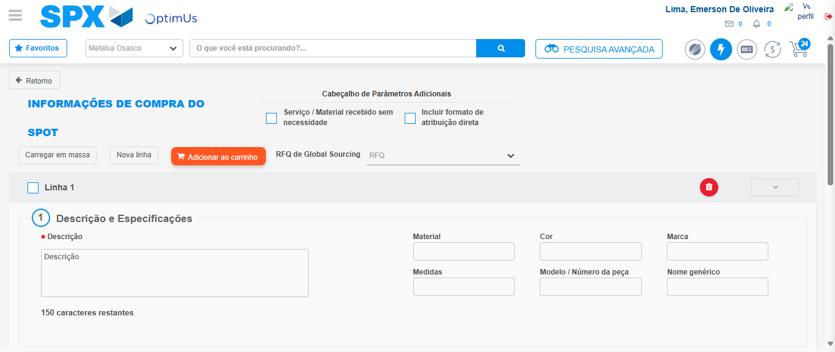Image file-name: QC_Testing-tc006_SPX_Dev5_Crear_Requisicion_Spot_Tipo_Cobro_Proyect_Urgent-1787009610630

Step 3 - Data Capture Spot Buy Requisition: Data captured correctly
Image file-name: QC_Testing-tc006_SPX_Dev5_Crear_Requisicion_Spot_Tipo_Cobro_Proyect_Urgent-1787009610952

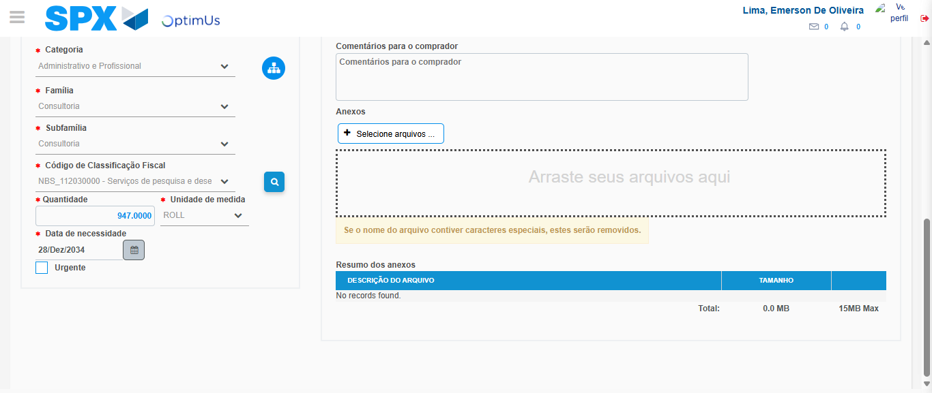Image file-name: QC_Testing-tc006_SPX_Dev5_Crear_Requisicion_Spot_Tipo_Cobro_Proyect_Urgent-1787009628599

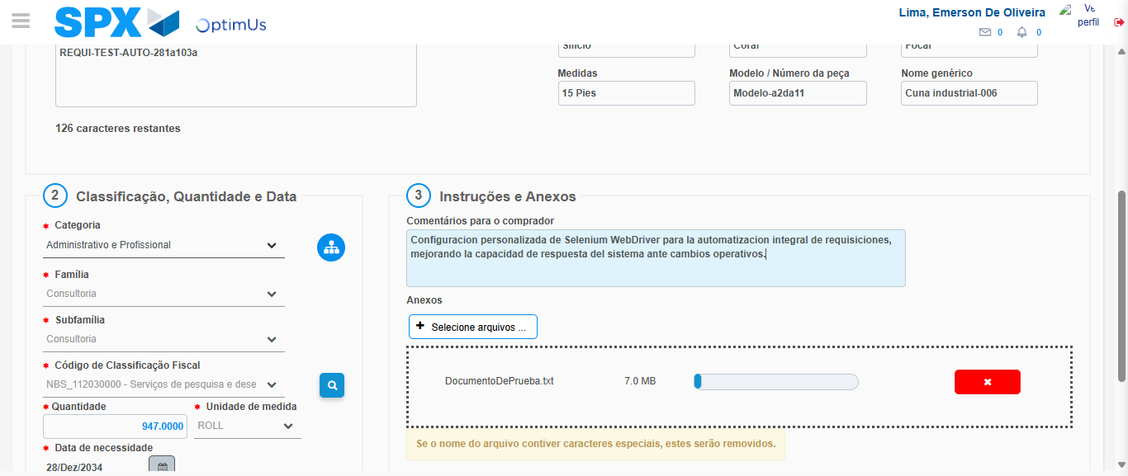Image file-name: QC_Testing-tc006_SPX_Dev5_Crear_Requisicion_Spot_Tipo_Cobro_Proyect_Urgent-1787009629479

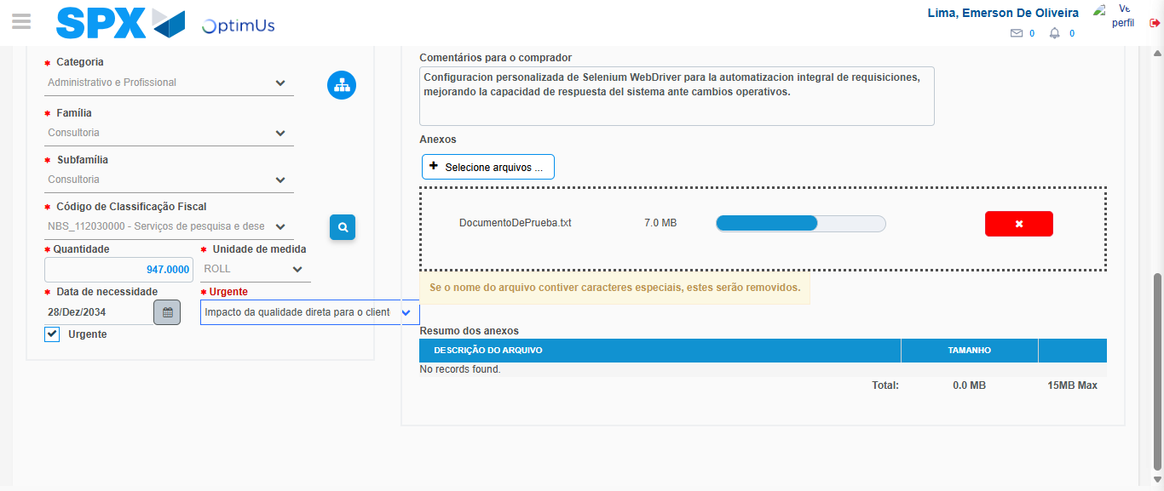Image file-name: QC_Testing-tc006_SPX_Dev5_Crear_Requisicion_Spot_Tipo_Cobro_Proyect_Urgent-1787009633355

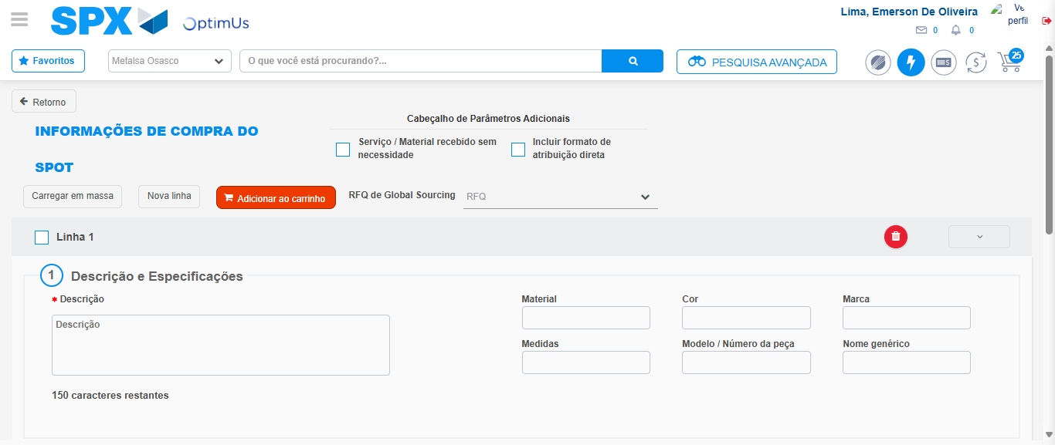Image file-name: QC_Testing-tc006_SPX_Dev5_Crear_Requisicion_Spot_Tipo_Cobro_Proyect_Urgent-1787009641605

Step 7 - Return to Main Page SPX : Return to Main Page SPX
Image file-name: QC_Testing-tc006_SPX_Dev5_Crear_Requisicion_Spot_Tipo_Cobro_Proyect_Urgent-1787009601451

Image file-name: QC_Testing-tc006_SPX_Dev5_Crear_Requisicion_Spot_Tipo_Cobro_Proyect_Urgent-1787009604092

Image file-name: QC_Testing-tc006_SPX_Dev5_Crear_Requisicion_Spot_Tipo_Cobro_Proyect_Urgent-1787009610630

Image file-name: QC_Testing-tc006_SPX_Dev5_Crear_Requisicion_Spot_Tipo_Cobro_Proyect_Urgent-1787009643887

Image file-name: QC_Testing-tc006_SPX_Dev5_Crear_Requisicion_Spot_Tipo_Cobro_Proyect_Urgent-1787009644087

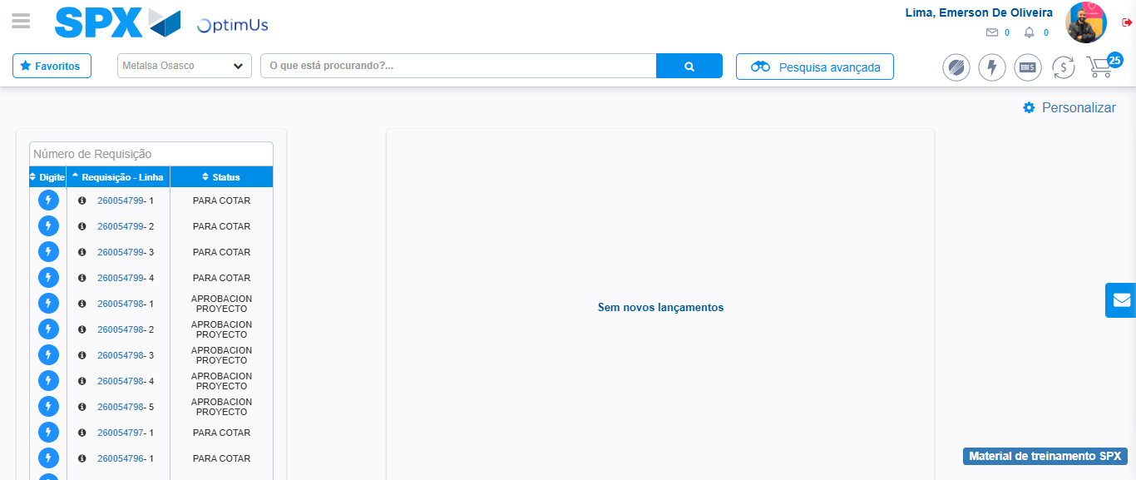Image file-name: QC_Testing-tc006_SPX_Dev5_Crear_Requisicion_Spot_Tipo_Cobro_Proyect_Urgent-1787009665161

Step 8 - Log Out : Log Out SPX
Image file-name: QC_Testing-tc006_SPX_Dev5_Crear_Requisicion_Spot_Tipo_Cobro_Proyect_Urgent-1787009665391

